|  |  |
| --- | --- |
|  | Diagrams |
|  |  |
| Generated 5/17/2018 | cc-project |
|  |  |

system_cases (system_cases.ndx)

From cc-project Package

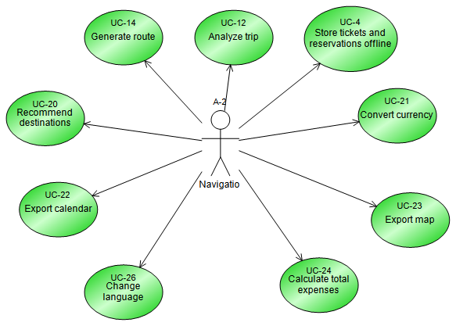

guest_cases (guest_cases.ndx)

From cc-project Package

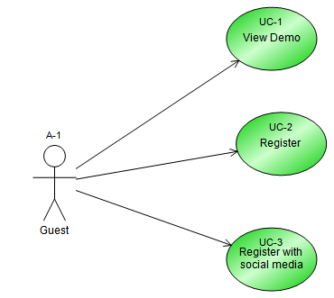

user_cases (user_cases.ndx)

From cc-project Package

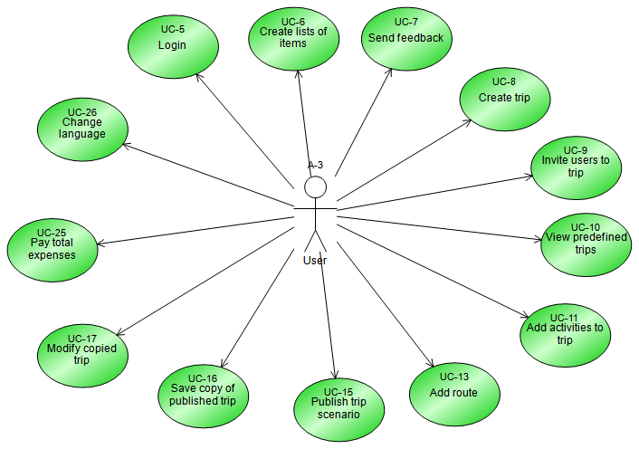

company_cases (company_cases.ndx)

From cc-project Package

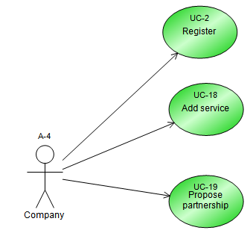

Activity Diagram (ViewDemoActivityDiagram.ndx)

From UC-1 View Demo Use Case

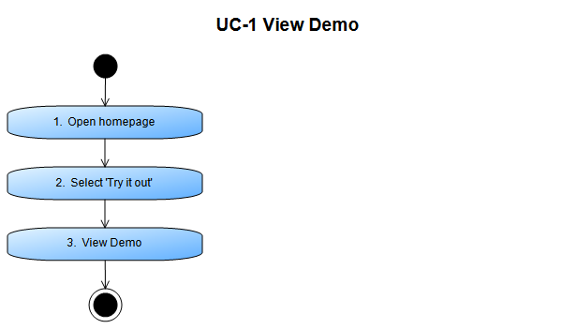

SequenceDiagram (SequenceDiagram.ndx)

From UC-1 View Demo Use Case

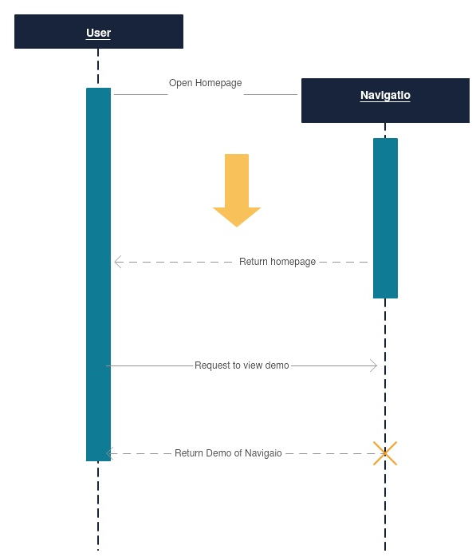

Activity Diagram (RegisterActivityDiagram.ndx)

From UC-2 Register Use Case

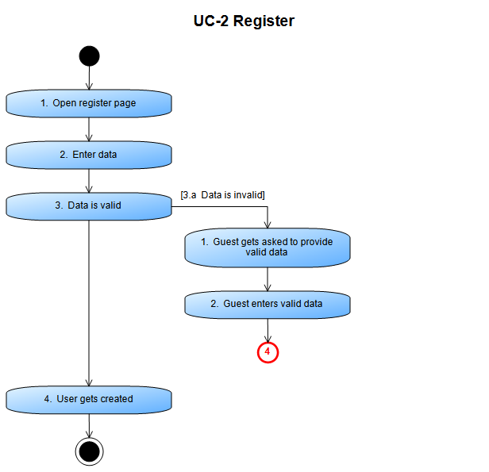

SequenceDiagram (SequenceDiagram3.ndx)

From UC-2 Register Use Case

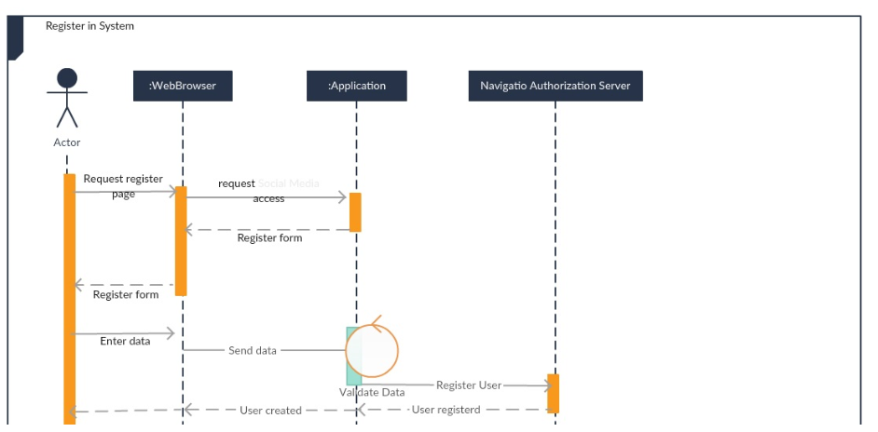

Activity Diagram (RegisterWithSocialMediaActivityDiagram.ndx)

From UC-3 Register with social media Use Case

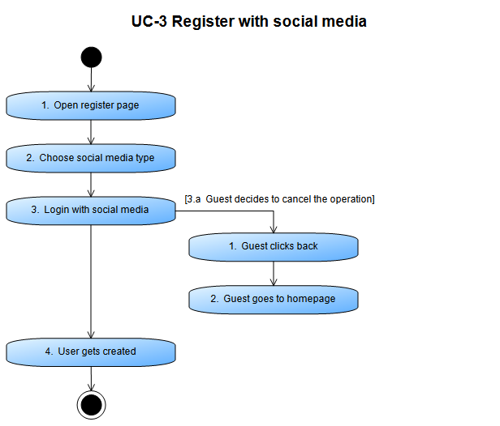

SequenceDiagram (SequenceDiagram2.ndx)

From UC-3 Register with social media Use Case

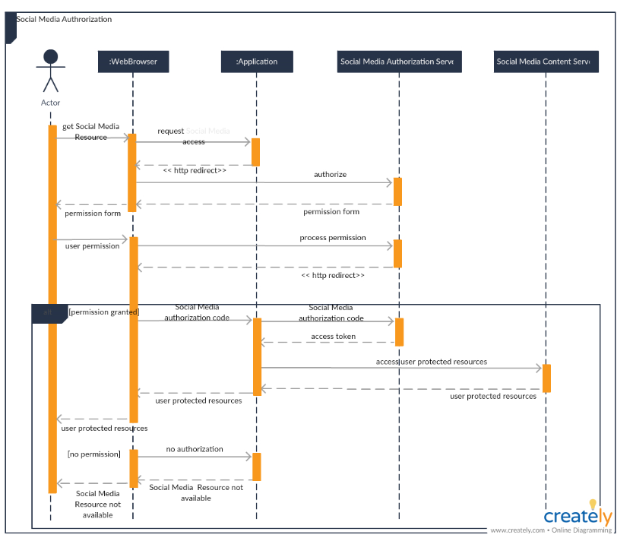

Activity Diagram (LoginActivityDiagram.ndx)

From UC-5 Login Use Case

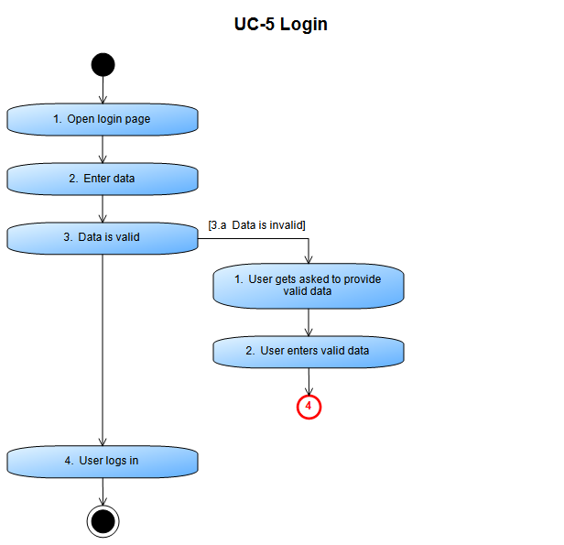

SequenceDiagram (SequenceDiagram4.ndx)

From UC-5 Login Use Case

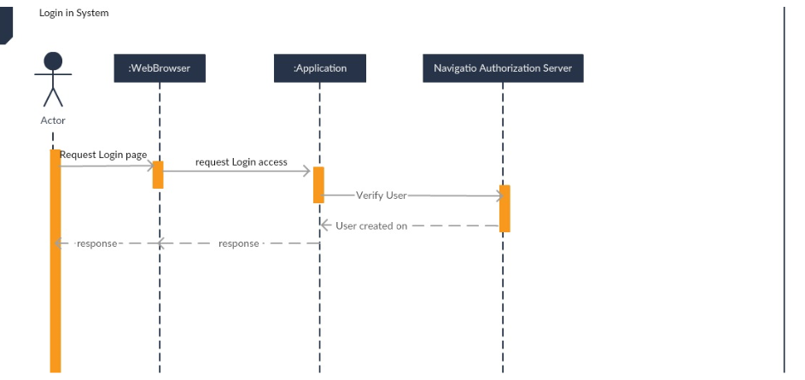

Activity Diagram (CreateListsOfItemsActivityDiagram.ndx)

From UC-6 Create lists of items Use Case

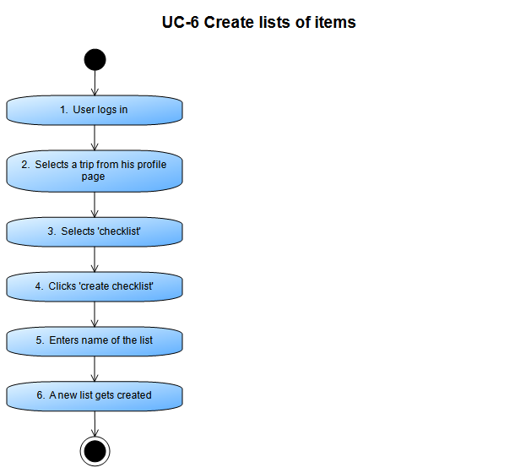

Activity Diagram (SendFeedbackActivityDiagram.ndx)

From UC-7 Send feedback Use Case

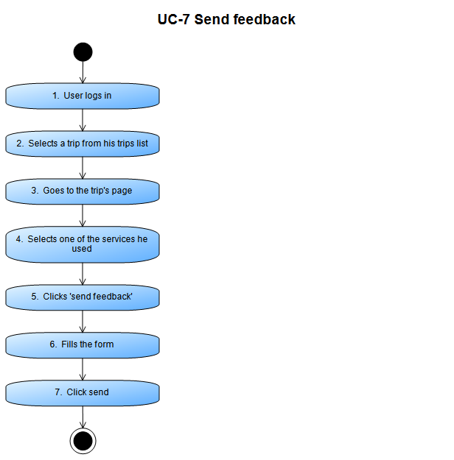

Activity Diagram (CreateTripActivityDiagram.ndx)

From UC-8 Create trip Use Case

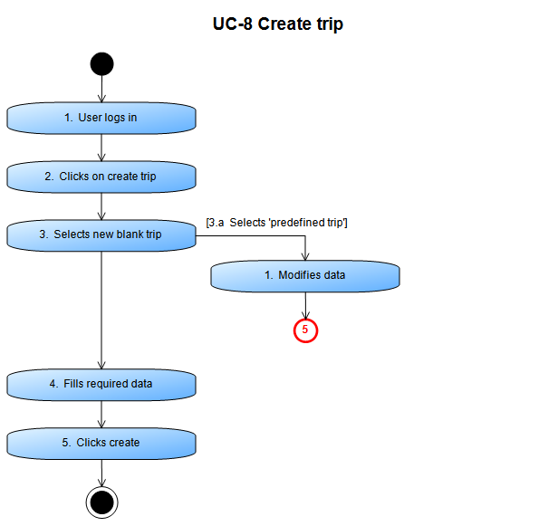

Activity Diagram (InviteUsersToTripActivityDiagram.ndx)

From UC-9 Invite users to trip Use Case

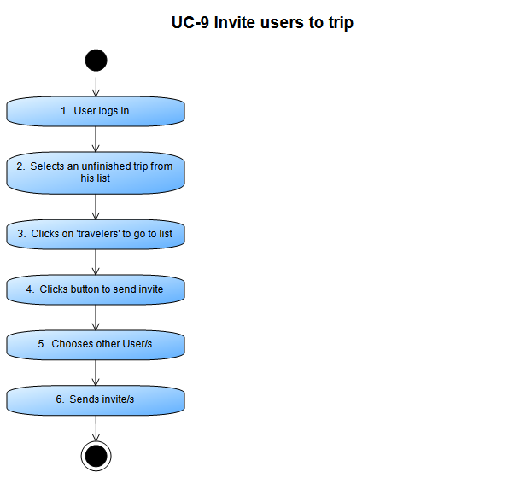

Activity Diagram (ViewPredefinedTripsActivityDiagram.ndx)

From UC-10 View predefined trips Use Case

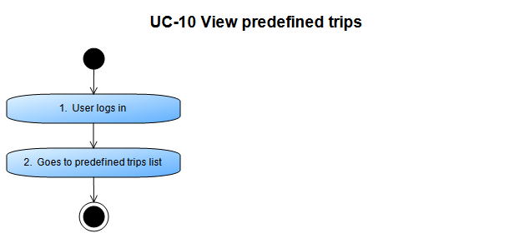

Activity Diagram (AddActivitiesToTripActivityDiagram.ndx)

From UC-11 Add activities to trip Use Case

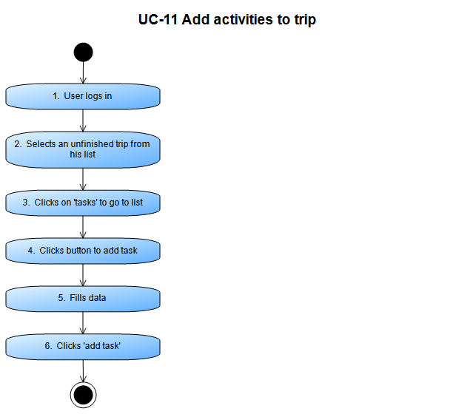

Activity Diagram (AnalyzeTripActivityDiagram.ndx)

From UC-12 Analyze trip Use Case

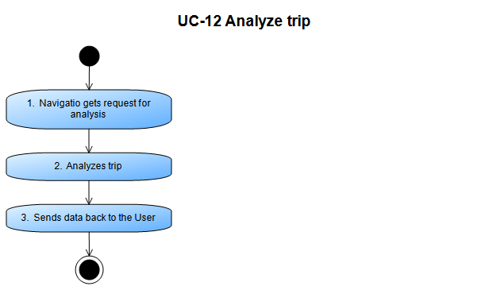

Activity Diagram (AddRouteActivityDiagram.ndx)

From UC-13 Add route Use Case

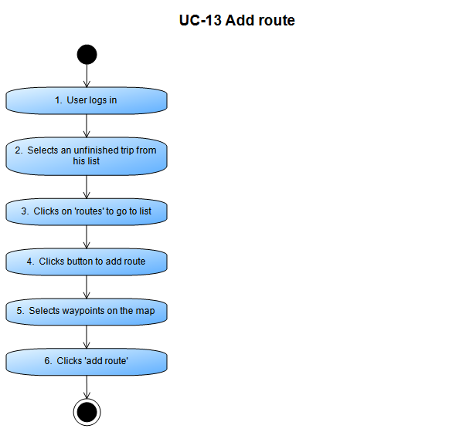

Activity Diagram (GenerateRouteActivityDiagram.ndx)

From UC-14 Generate route Use Case

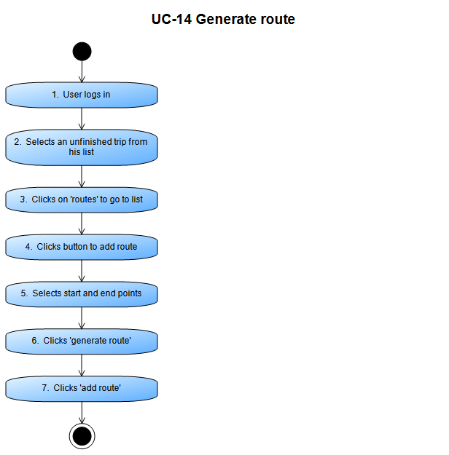

Activity Diagram (PublishTripScenarioActivityDiagram.ndx)

From UC-15 Publish trip scenario Use Case

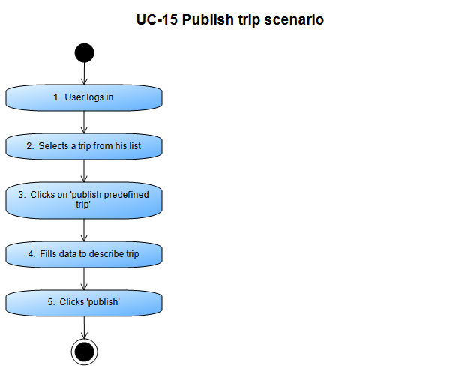

Activity Diagram (SaveCopyOfPublishedTripActivityDiagram.ndx)

From UC-16 Save copy of published trip Use Case

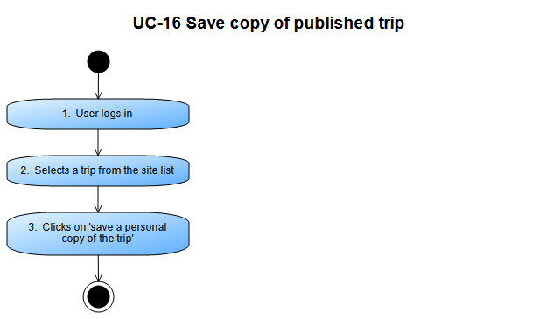

Activity Diagram (ModifyCopiedTripActivityDiagram.ndx)

From UC-17 Modify copied trip Use Case

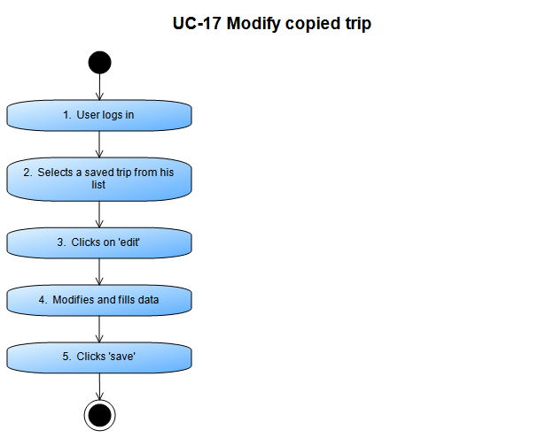

Activity Diagram (AddServiceActivityDiagram.ndx)

From UC-18 Add service Use Case

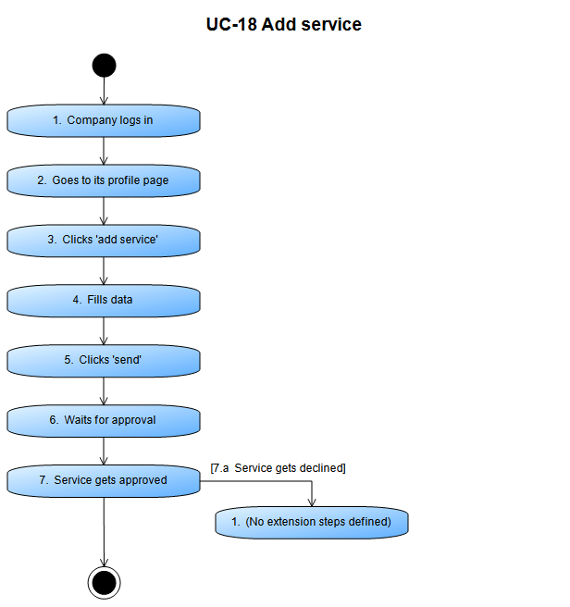

Activity Diagram (ProposePartnershipActivityDiagram.ndx)

From UC-19 Propose partnership Use Case

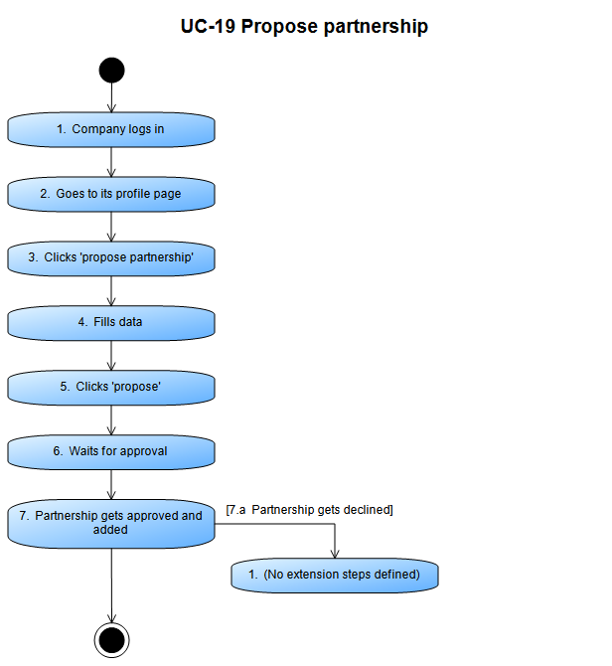

Activity Diagram (RecommendDestinationsActivityDiagram.ndx)

From UC-20 Recommend destinations Use Case

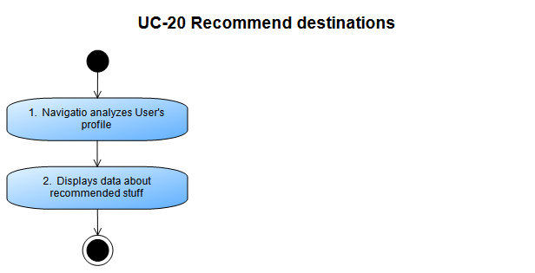

Activity Diagram (ConvertCurrencyActivityDiagram.ndx)

From UC-21 Convert currency Use Case

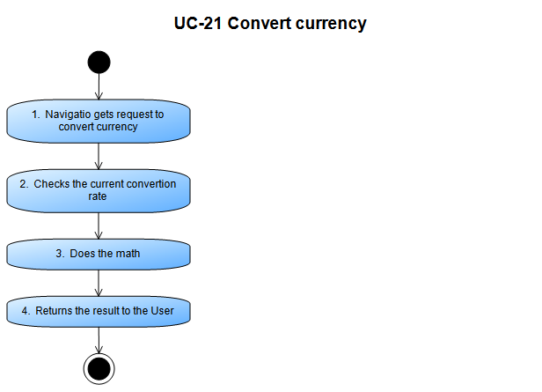

SequenceDiagram (SequenceDiagram6.ndx)

From UC-21 Convert currency Use Case

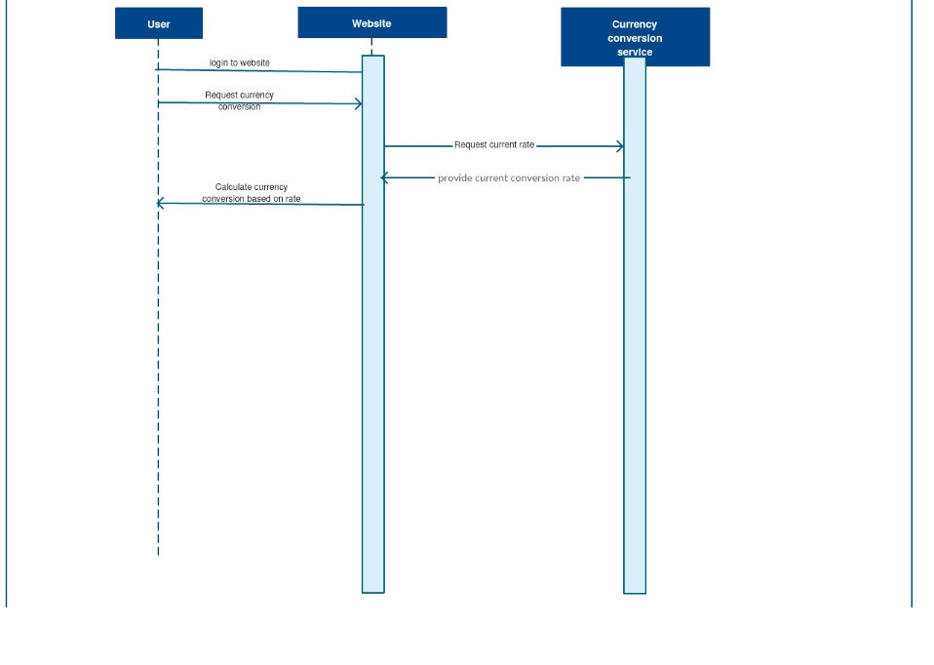

Activity Diagram (ExportCalendarActivityDiagram.ndx)

From UC-22 Export calendar Use Case

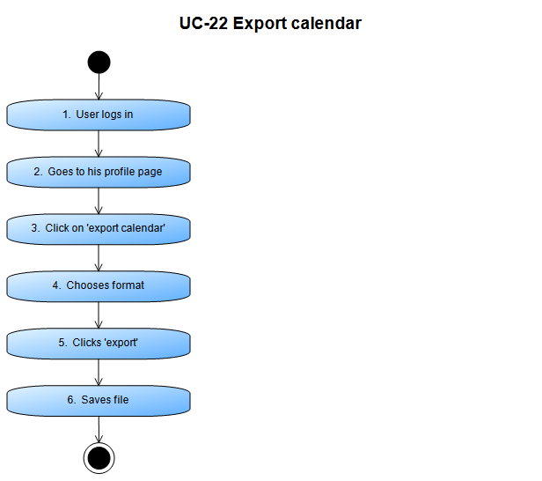

Activity Diagram (ExportMapActivityDiagram.ndx)

From UC-23 Export map Use Case

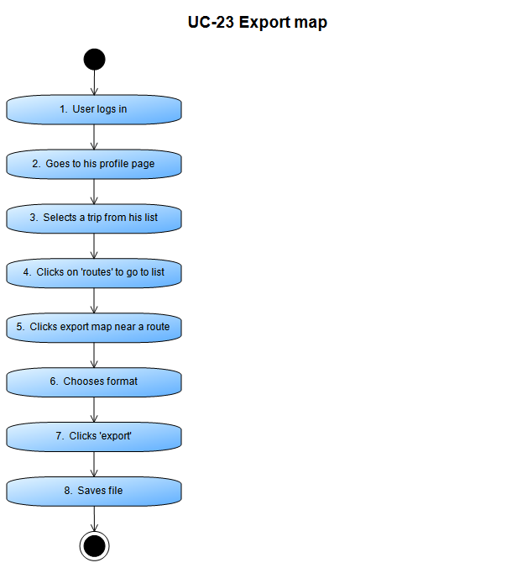

Activity Diagram (CalculateTotalExpensesActivityDiagram.ndx)

From UC-24 Calculate total expenses Use Case

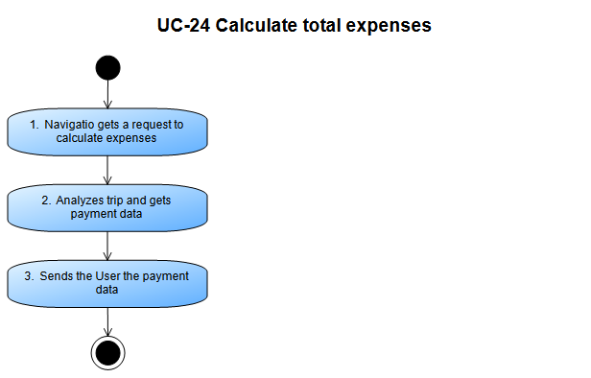

Activity Diagram (PayTotalExpensesActivityDiagram.ndx)

From UC-25 Pay total expenses Use Case

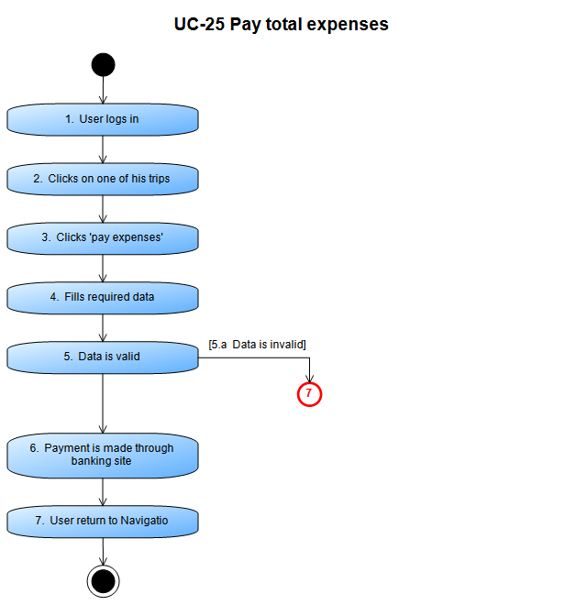

SequenceDiagram (SequenceDiagram5.ndx)

From UC-25 Pay total expenses Use Case

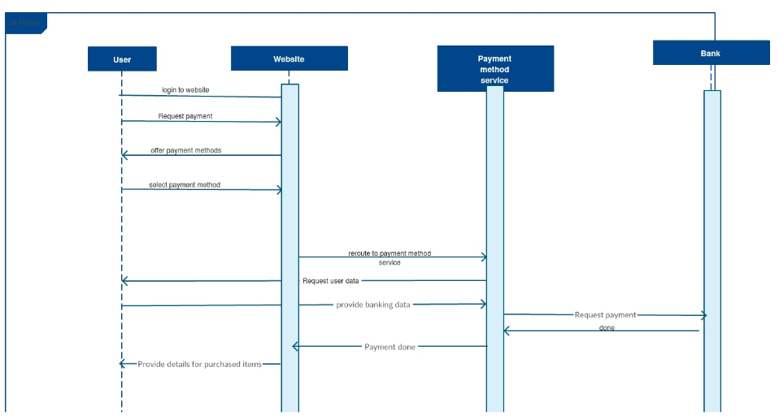

Activity Diagram (ChangeLanguageActivityDiagram.ndx)

From UC-26 Change language Use Case

